«AddressBlock»
«GreetingLine»
Best wishes to you «First_Name» «Last_Name». I hope you are you are doing well. We would like to THANK YOU for participating in this Athletic Sports Camp. The uniform size selected by you was «Uniform_Size». This T-shirt should be used when arriving on the camp grounds so that identification could be made easily.
The following data most be used to make a successful camp experience:
- Pickup location: Any Location, Port – Of – Spain
- Departure: 8:00AM
- Return Time: 3:00PM
Please view the following table that shows the prices for each sport and the discount applied to all full campers who paid in full:
Sports Name | Price US | Discount Applied TT
Football | $120 | $144
Basketball | $200 | $180
Netball | $225 | $270
Hockey | $275 | $330
Swimming | $350 | $420

We would like to thank you again for your support and participation in the Athletic sport camp.
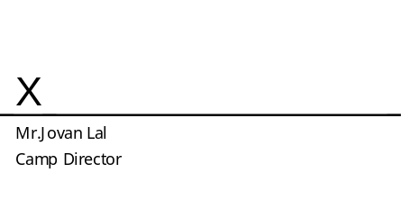
Jovan Lal
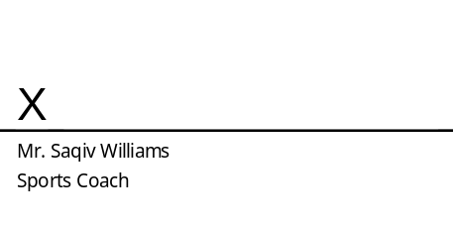
Saqiv Williams
Saqiv Williams

Rajesh Sharma
Rajesh Sharma

